**4/6/2017**

**Project Done By**

**Team: CS 660 Groups - WIN 17 1**

**Mital Patel**

**Pinal Patel**

**Bhumikka Golwala**

**Querida Jonquil**

**Rahul Parekh**

**Chirag Modi**

**Ankit Rao**

**Vivekananda Ravva**

**Managing Process, Resources and Risks**

**Final Project: Data Center Migration from**

**Physical data center to Microsoft Azure**

**ABSTRACT**

Data Center Migration Critical business application from a physical data center to Microsoft Azure (Cloud /PaaS) Consider that a disaster could happen during the migration. In this project, we are going to describe the Project Development Phases and related project knowledge areas. The main assumption for project time duration is six month. As we know about different strategies in business project, consider the basic things like **Project Scope, Project Time** and **Project Cost** because one out of three is changed effect on other two. Using this three we explained Five Process of Project is **I**nitiate, **P**lanning, **E**xecuting, **M**onitoring & **C**ontrolling and **C**losing and 10 knowledge areas. In this documentation describe Microsoft Azure how to analyze, managed, create the project and describe the role of team members or stakeholder.

**TABLE OF CONTENTS**

|  |  |  |
| --- | --- | --- |
| Index No. | Contents of the Project | Page No. |
| 1. | **Project Integration Management** | **1** |
|  | * **Task-1** * **Task-2** * **Task-3** * **Task-4** * **Task-5** | **1**  **3**  **5**  **7**  **10** |
| 2. | **Project Scope Management** | **12** |
|  | * **Task-1** * **Task-2** * **Task-3** | **12**  **15**  **16** |
| 3. | **Project Time Management** | **18** |
|  | * **Task-1** * **Task-2** * **Task-3** * **Task-4** * **Task-5** | **18**  **21**  **23**  **27**  **29** |
| 4. | **Project Cost Management** | **31** |
|  | * **Task-1** * **Task-2** * **Task-3** | **31**  **33**  **35** |
| 5. | **Project Quality Management** | **36** |
|  | * **Task-1** * **Task-2** | **36**  **41** |
| 6. | **Project Human Resource Management** | **44** |
|  | * **Task-1** * **Task-2** * **Task-3** | **44**  **50**  **51** |
| 7. | **Project Communications Management** | **53** |
|  | * **Task-1** * **Task-2** | **53**  **55** |
| 8. | **Project Risk Management** | **56** |
|  | * **Task-1** * **Task-2** * **Task-3** * **Task-4** | **56**  **59**  **61**  **63** |
| 9. | **References** | **65** |

**Project Integration Management**

* **Task 1: Prepare a weighted decision matrix to evaluate people applying for the Project Manager Job. Outline what your criteria are and how each one weighs in the decision making. Write a one page paper on how you made your selection and summarize the result.**
* Nowadays, Microsoft azure is most famous in IT fields. The company need experience, practice, and good knowledge person who handle all the task of Microsoft azure project and guide people to do best work. Need a project manager who determined for his/her work. In this project, project manager is highly organized, multitasker, taking responsibilities and guide or lead people who working under project manager, good communicator, have good knowledge about negotiation like where and when negotiate the things, detail oriented, quickly recognize issue and solve easily, enough technical skills. These are the basic skills in the project manager and other important technical skills the company want in project manager is this
* Project manager has key strategy to work successfully on azure platform
* Project manager has power to lead technical team and get solution for project.
* Project manager has ability to drive project improvements to adoption and accelerate environment.
* Project manager should be identified trend and solutions which is applicable in the domain.
* Project manager is quickly ramping into the new product which is running on meanwhile.
* Project manager has experience to develop HPC project, architecture project, technical lead, IC developer.
* Project manager have a good understanding of Azure, Office 365, hosted Active Directory, Windows Azure, Active Directory, Cloud Computing, MS Office 365, etc.
* Project manager have good understanding of Microsoft Server products and Active directory.
* Project manager have Strong cross grouping to do collaboration skills
* Experience with cloud services, such as Microsoft Azure, is a plus
* Any kind of project manager is important because of them project achieve success within time frame after so many meet milestones. That person set deadline and budget with reach the goal of the project.
* **Task-2: Develop a business case which will include and ROI and any needed financials to justify why the business needs to do this project**
* **Business Case:**

The following document revises the need of the project through business vision, business need, expected benefits and strategic fit. As we see the Gantt chart has the data of schedule and the budget. The goal of this project is to upgrade the physical memory to cloud, where the business application is accessible to everyone. This type of migration requires IT professionals to develop test cases, work on the memory and security related aspects. Apart from IT professionals, the QA technicians also play the role of providing a detailed report on the project success.

The main idea behind this project is to develop a cloud based platform to store business applications. This decreases the uncertainty of memory usage in the physical location. Through cloud, the application is made available to anyone who wants to access it. The security increases there by keeping certain data privy only to the head of the organization. The sponsors will be benefitted with this as their investment will increase as the project reaches new heights of success. The stakeholders who are our end users also get the profit of accessing data through cloud. File exchange becomes easy as the manual work decreases. To have more benefits, a few features can also be added to the business application. Keeping these in mind, the number of workers, the schedule and the budget are is prepared. This document justifies every penny spent on the project to benefit the sponsors and the developers.

ROI is generally communicated as a rate and is ordinarily utilized for individual business choices to contrast an organization's profitability or with think about the effectiveness of various projects.

The return of investment calculation formula is: **ROI = (Net Profit / Cost of Investment) *100**

An execution measure used to assess the effectiveness of a speculation or to think about the productivity of various diverse projects for Microsoft Azure. The ROI count is adaptable and can be controlled for various employments. A Microsoft may utilize the estimation to analyze the ROI on various potential speculations, while a financial specialist could utilize it to compute an arrival on a stock. ROI is more useful profitability ratio because it is flexible. At the time of calculating of ROI for Azure to compare investments and it’s important to use the same inputs to get better result of comparison.

Microsoft Azure is an adaptable cloud stage, intended to empower clients to rapidly assemble, oversee and send applications. It touts the capacity to help any engineer or IT proficient lift efficiency through coordinated devices, pre-assembled formats and oversaw administrations that streamline fabricating and overseeing endeavor, portable, Web and Internet of Things applications speedier. Forrester as of late explored the effect Azure PaaS can have on associations' main concern, at last finding that organizations changing from Azure IaaS to Azure PaaS understood a 466 ROI. Associations changing from on-start foundations to Azure may expect much higher returns, as indicated by the exploration mammoth. Building up our application without PaaS? We wouldn't have done it. To be honest, the additional time and assets would have wiped out any benefit that we have produced. Forrester's discoveries were gotten from considering the ROI acknowledged by associations with quite a long while of experience utilizing Azure IaaS moving to PaaS. The organizations use administration offerings like App Service, SQL Database, and Azure Active Directory.

* **Task-3: Prepare a Project Charter for the chosen project**
* **NOTE:** The project charter is attached as “Excel File” with this document and also see in given below figure:

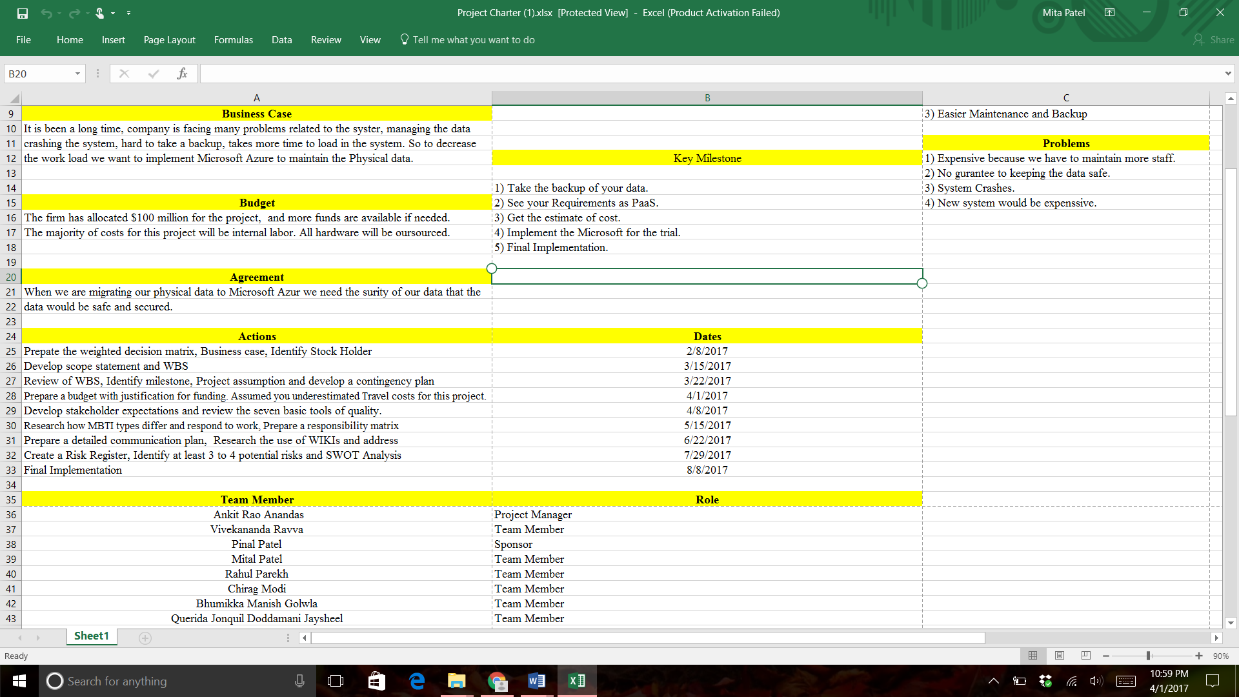

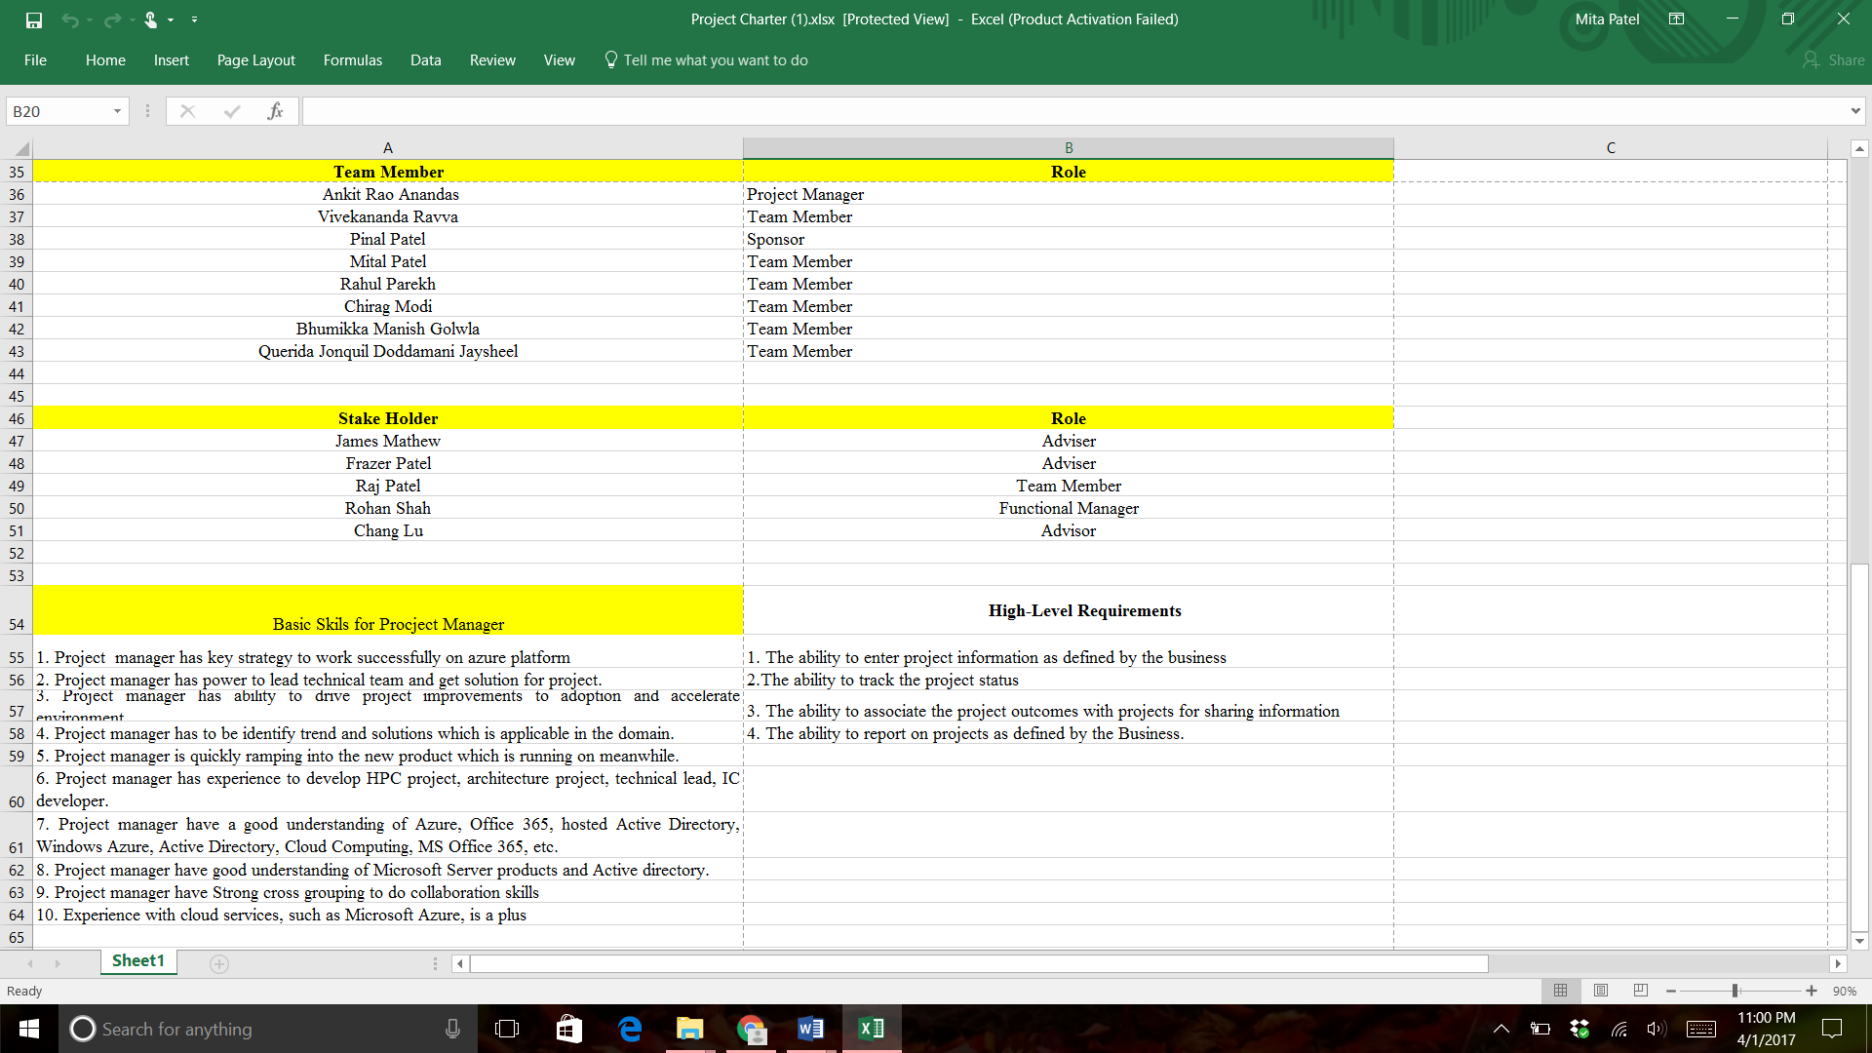

* **Task-4: Change on a project is invertible and must be managed and decided on quickly. So, prepare a Change request form and write a one page paper on how you plan to manage changes on the project.**

|  |  |  |  |  |
| --- | --- | --- | --- | --- |
| **Change request form** | | | | |
| **Project:** | | | | **Date:** |
| **Change requestor:** | | | | **Change No:** |
| **Change requestor position:** | | | | |
| **Change category:**  **Schedule Budget Personnel Requirement**  **Scope testing Resources Documentation** | | | | |
| **How does this change effect to project? :**  **Corrective actions preventive actions Defect repair Updates** | | | | |
| **Description of the change requested:** | | | | |
| **Describe the reason of change requested:** | | | | |
| **Effect on project if changes applied:** | | | | |
| **Priority of changes:** | | | | |
| **Describe the risk if implemented:** | | | | |
| **Describe the risk if change not implemented:** | | | | |
| **Describe alternatives for change:** | | | | |
| **Date to begin change in project:** | | **Date to end change in project:** | | |
| **Impact on:**  **Budget schedule staffing Quality stakeholders** | | | | |
| **Estimated cost and resources required:** | | | | |
| **Technical changes need in project:** | | | | |
| **Change reviewed by Name and position:** | | | | |
| **Decision:** | | | | |
| **Reasons for decision:** | | | | |
| **Members involved in project change** | **Name:** | | **Position:** | |
|  |  | |  | |
| **Final approval by:** | | | | |
| **Signature:** | | | | |
| **Date to implement:** | | | | |

It is necessary to deliver a project successfully. The objectives should be set and obstacles should be mitigated to complete a project. When physical data are transfer to Azure, there is need to manage changes on project. Therefore, by using change request form all the information will be collected related to project change. I will identify change request identification from request personnel and assess the request. I will rectify the request that is it really needed or can be avoided. If it is going to be change then, I will analyze the change. Meanwhile, the project cannot be cancelled and the remaining part will work as it should be. As there is 6 months’ project, so back up plan also be ready. The architecture design that how all data will be transfer to azure will be decided on documents and step by step the decision will be taken. Meanwhile, funding, cost, sponsor and team manager requirements will be analyzed that to tackle unrequired issues which can raise during transfer of data.

* The change control boards in which project manager, project sponsor and another stakeholder will be included. They will do meeting to review request changes and present among all board member.
* After that control board set objective for changes and those changes are approved by board members will be in schedule and make budget for it.
* I will prioritize the work as per qualified and analyzed in system. Minimize the work which is impactful to success of project.
* Team members will be empowered to add required documents and process while changes are going on.

Therefore, to manage changes in a project after surety of data transfer need to take care of budget which is decided in project charter. Also, necessary to take care of objectives of project that is to transfer data quickly and manage backup if there is fault in transfer. The change is project plan is difficult to manage if there is no backup plan and no budget set. To manage plan, the project manager should do SWOT analysis before finalization of all process. Moreover, the benefit of transfer data to Azure should also measure otherwise blunder in project may effect on cost of organization. Therefore, the change request form will be helpful if project plan change.

* **Task-5: Identify the key Stakeholders and Prepare a Stakeholder Matrix**
* **Stakeholders:**

In projects outcome, the managers or members of the company’s make its activity or decision. This decision or activity directly or indirectly affects the stakeholders which is a group of members, an individual or organization. As per the project and companies structure there are different stakeholder matrix.

* **The stakeholder matrix involves 3 types of matrix which is:**
* **Strong matrix:** there are many powers and authority which is handled by stakeholder. They take the decision than only the process is continued. He not only takes decision but controls the whole project with that he controls the budget of the project. The example is project manager.
* **Balanced matrix:** in this type of matrix functional manager and employees divide the project responsibility and try completing the project on time. They also try controlling the budget of the project. Employees and functional manager tries to complete the project on time and perfect in quality.
* **Weak matrix:** in this matrix, the response is very slow. They are not concerned with the activity around they only deal with profit of the project. They will be the part of the project but won’t get involved in any type of decision or administration work.
* **The stakeholder for the project are as follows:**

1. Project manager
2. Board of Members
3. Functional manager
4. Employees
5. Analyst
6. Investors
7. Customer

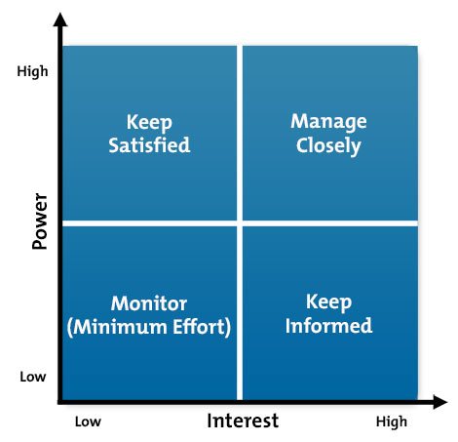

In the above matrix:

1. Keep Satisfied: in this part of the matrix Board of Members are major power in this project. They will take all the decision and procedure to complete the project.
2. Manage closely: for this project, Project Manager has highest interest in the project. As he takes half of the decision, controls the budget of the project, and controls the period of the project.
3. Monitor: in this project who has less power and less interest in this project comes in this category. Analyst, employees, and functional manager comes in this category.
4. Keep informed: in this category customers and investors are interested in this project. They don’t have power to take decision but they are very much interested in using the finish product. Where investors are very keen to apply this in their business and customer are keen to apply in there day to day life.

**Project Scope Management**

* **Task 1: Document requirements for your project, include a requirement traceability matrix and include a list of questions you will like to ask the project sponsor.**
* **PLAN SCOPE MANAGEMENT:**

Microsoft Azure’s data migration is facing many problems so, Project Manager is making plan related data managing and longtime migration for physical data and try it easy for work load.

As Project Charter and Matrix, we know about the scope of project. Is the data effected by disasters?? Project plan protected data from disaster. All these questions are suggested Project scope likes business case, key Milestone, Budget of project, some agreement for security and decide role of every employees each part.

* **COLLECT REQUIREMENTS DOCUMENT:**

The document discusses about the project specifications, products produced and resources required to establish this migration successfully. In these terms, the document is divided into four parts. There is a requirements document, a traceability matrix, and a list of questions we can discuss with the project sponsor.

**Requirement elicitation:**

The process of migration from physical data to cloud needs a lot of security and a summary of the features of the business application. The elicitation shows all the collection of products used in developing the project. The elicitation defines the rest of the project and the process of developing it. We collect data like the current software the company uses and check if it is compatible to move the data to Microsoft azure, the memory of the data.

**Requirement Analysis:**

Analysis studies on the measures we take to meet the requirements (or) deliverables from elicitation. We make sure the data security is perfect and see how much information is privy to the people accessing the application. We study the possible flaws that could happen in the process of migration. For this we study and try to collect the external data of the project carried out by other companies and set up goals to make sure we don’t miss out on any minor details that could create a tension later in the project development. More analysis depends on the IT department that carries out the process and the benefit that is shared between the company and the IT department. More analysis is based in the requirements of the stakeholders and the sponsors.

**Requirement Specification:**

We specify in the document the milestones like budget, schedule, hardware changes to the application before the process starts. The main specification here is the labor cost which specifies if the IT developers use a specialized QA Testing department to see the quality of the migration or self-test it as they develop the project.

**Requirement Validation:**

This is an iterative process that goes on as we keep approaching the end of the project. A validation is done at every step of the migration so there will not be a flaw in the process or a security breach as the application cuts through the cloud. Therefore, the validation document is completed for the first stage where we made sure the SRS document lists all the specifications without any error.

* **REQUIREMENT TRACEABILITY MATRIX:**

The following table has four requirements so far. The matrix adds more components as we keep working in it further and see all the changes we can make based on the validation. This is an iterative process as well.

|  |  |  |  |  |
| --- | --- | --- | --- | --- |
| Requirement Number | Name | Category | Source | Status |
| R1 | Operating System | Software | Charter & requirement elicitation | Created a perfect view to migrate sets of data |
| R2 | Physical data | Hardware | Charter & Scope | Application takes a large space |
| R3 | Specifications | Software & Hardware | Charter & requirements document | Documentation done |
| R4 | Testing | Hardware | IT department | Under development |

* **LIST OF QUESTIONS:**

There are a few details we would discuss with the Project Sponsors. They include:

1. The budget and the schedule of the migration. The schedule follows 6 months but there could be a few changes made to it in case of as extra testing or added feature to the application.
2. We discuss if we need specialized quality assured testers to test the project or leave it in the hands of the developers for giving a Quality Assurance report in the end.
3. Further changes in scope creep and the suitable technique to use for migrating the application.

* **Task 2: Develop a scope statement for the project. Be specific and make assumptions as needed**
* **Define Scope: “**As there were interest from many corporate customers which were delivered in Azure, we decide to have Azure Migration lab at the Microsoft technology centers. The project will feature a new iCloud based memory unit to store business applications. It is a migration of data center from physical data center to Microsoft Azure.”
* **Validate Scope:** This project will be complete in 6 months’ time. The company is willing to upgrade their technology and data storage from a physical center to cloud. This migration includes business application, files exchanged manually, upgrade in software and new added features based on the sponsors’ interest. This project will facilitate productivity via internet where everyone can access the applications from anywhere across the globe. This project will be complete by August 2017. The resources allocation, Gantt chart and requirements documents further deliver the details of project methodology, budget, and schedule.
* **Limitations:**

Majorly network bandwidth should be properly maintained as there is lot of traffic while migrating to cloud and proper planning should be done for managing the system downtime and eliminating security risks. Nevertheless, there are solutions available in Azure itself to take care of security risks, backup and recovery which helps in disaster management.

* **Task 3:**  **Develop a Work Break down Structure (WBS) using Microsoft Projects or Microsoft Word. Be sure this document is based on your scope statement, stakeholder requirements and other pertinent information. Make sure you have a Gantt chart to accompany your WBS. You MUST use Microsoft Projects for your Gantt chart. Do not enter duration or dependencies yet for the tasks. Consider all the 5 phases of Project Lifecycle as you work on this knowledge area**
* **Create WBS:**

|  |  |  |
| --- | --- | --- |
| * Physical data center transfer to Microsoft Azure | 1.1  Initiation | 1.1.1 Business case |
| 1.1.2 Project charter |
| 1.1.3 Plan scope management |
| **1.3.1** Key mile stone |
| **1.3.2** Budget of project |
| **1.3.3** Agreement |
| 1.2  Document | 1.2.1 Requirement gathering by JAD session |
| 1.2.2 Create BRD document |
| 1.2.3 Approved BRD |
| 1.2.4 Create FRD document |
| 1.2.5 Approval FRD document |
| 1.2.6 Available for technical team |
| 1.3 Execution | 1.3.1 Design system |
| 1.3.2 Arrange meeting with managers |
| 1.3.3 Produce hardware and software |
| 1.3.4 Review with client detail |
| 1.3.5 Testing |
| 1.3.6 Deployment |
| 1.4 Maintenance and control | 1.4.1 Revision |
| 1.4.2 Problem identification |
| 1.4.3 Meeting with manager |
| 1.5 Closer | 1.5.1 Implementation of project |
| 1.5.2 Compare actual with projected work |
| 1.5.3 Complete the project |

* **Control Scope:**

**Gantt chart**

* This Gantt chart is send you in “MS Office Project file” and you can see in below image.

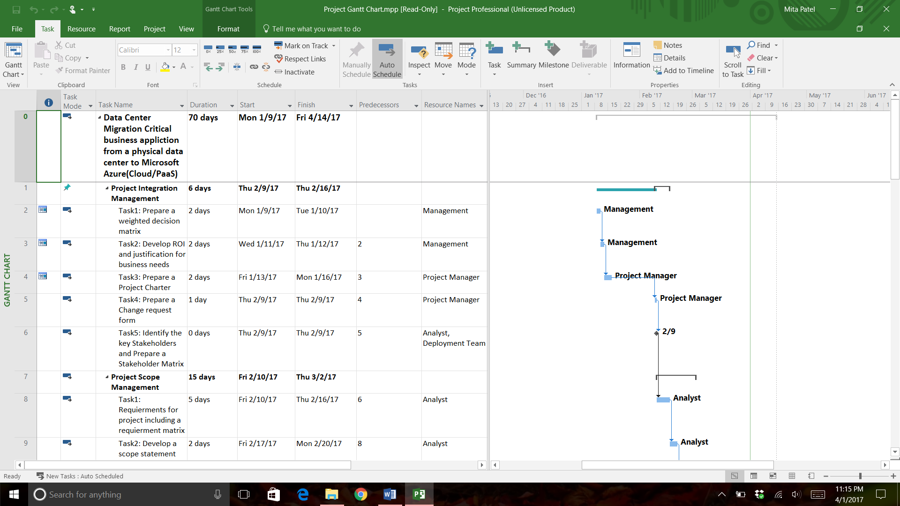

**Project Time Management**

* **Task-1: Review the WBS prepared and add 3 to 4 more tasks/activities. Write a one page paper describing the new activities.**

A work breakdown structure (WBS) is a chart in which the critical work elements, called tasks, of a project are illustrated to portray their relationships to each other and to the project.

For the implementation of the physical data to the Microsoft azure we have divided into five parts so that we will know in which steps what we have to do in there.

First step is the initialization. In that step we are mainly we are focusing on the Business Case, Project Charter and Plan Scope Management. In the Business Case, it is just a normal document which is mainly made to convince the decision maker who is going to approve the actions. In the project charter, it is an outline of the project objectives, identify the stockholder and define the authority to the manager. So basically, it is a reference of the authority to projecting the future of the project. In the Project Scope Management, we need to put our Milestones, what is the Budget of the Project and the third is all the agreements which we are going to do with Microsoft Azure.

The second Step is the Document. In the part of the Document we need to put the checklist which we are going to gather. In our checklist, we need to prepare, JAD Session, BRD document, FRD document. In the JAD session, JAD means Joint Application Design. It is mainly used for the Prototyping life cycle area of the dynamic system development method. The main object is to collect the business requirements when we are developing a new information system for a company. In the Business Requirement Document (BRD), there are all the requirements are listed for our business. BRD is mainly emphasis What is required for the business rather than how to achieve it. In the document of FRD, it is a functional required document. Mainly, FRD performs same as a contract. It is an agreement in between the developer and the client. Developer agrees to provide capability specified and client agrees to find product satisfactory which developer agrees to provide. So, in the second step we need to gather JAD session, create and approve the BRD and FRD document.

The third step is the Execution. In this step, we need to design our system with our developer, arrange the meetings with our managers, Produce Hardware and the Software, review the client, testing and deployment. So basically, in this step we are going ahead in our project which is main part. First, we need to design the system on the basis of our requirement. If we want to we can arrange some meetings with our manager too. The meeting is basically conducted for the more suggestions or finalizing. Once we finalize the design we can go ahead in the developing the hardware and the software. And the following part would be review, testing and the deployment.

The fourth step is Maintenance and Control. After the review, testing and the deployment we are going to revise the system. In the revise the system we are checking the whole system that the system is working fine or not. If the system has any problem we need to identify the system. Sometimes if the problem is very serious, all the manager also has to meet at the same time.

The fifth step is closer. After the testing and maintenance, we need to close the project. So, in this step we are mainly going to implement all the data into our system after solving all the problems. Furthermore, if everything is working fine, we need to close the Project.

**Additional Steps:**

1. **System Analysis and Requirements**

After the stage of the planning we need to decide that we are planning to implement our physical system into the Microsoft Azure. But did we think about the requirement of the system. It is being a year we are in the business. It is possible that we do have the old system. Furthermore, if we implement that into our system, it would be slow. So before that we need to decide that would be the requirements of that implementation. And if it requires the update of the system we need to update the system before the implementing.

1. **Component Design**

Component design is also a one type of the design itself. However, component design is also known as a Detailed design. So, it will show that how any particular component will work and communicate with other components. There is not likely to be a document covering all component designs as they are designed by different people. In many cases these designs are done by coders themselves.

## **Demonstrate Phase**

The Demonstrate phase is the **Test** stage and involves **proving**that the software system meets each of the designs, specifications and requirements in the Decide and Design phases. An explanation of the various types of testing is in the [Types of Testing](http://www.coleyconsulting.co.uk/testtype.htm) article.

1. **GAP Analysis**

In the GAP analysis, it refers to comparison. In the company, GAP analysis is involving the comparison of the actual performance and desired performance. If an organization does not make the best use of current resources, or forgoes investment in capital or technology, it may produce or perform below its potential.

1. **Meeting for the gathering the documents.**

When we are planning for the implementation, all the documents. For the safety purpose, we can meet for the documents requirements. The main purpose of the requirement is not for forget any document.

1. **Technical require document**

In the part of the documentation we can add the TRD. The TRD document is mainly made for the technical requirement. When we are implementation something into our system we need to know that we are meeting the requirements of not with the system. For that we need to make sure before the implementation.

* **Task-2: Identify at least 3 or 5 Milestones for this project. Write a one page paper describing the milestones using the SMART Criteria.**

SMART criteria are one of the project methodology which is used in project management by the project manager to measure the outcomes of the project and also the project phase. SMART criteria consist of 5 points which are:

**S: Specific**

While transferring the physical data center to Microsoft azure there are some roadblocks or milestone which will come across during the activity.

* Testing the project
* Including extra application details that will be accessible by company separately.
* Extracting coding for extra application

**M: Measurable:**

Through project tracking we can remove some solution to the project. Project tracking helps to measure various activity running in the project. Through mind mapping tool we can find where we can face problems and how much time each level if project will take. It also helps us to remove solution to problems. In this phase, we will test the project and see if the current software is compatible during the test.

**A: Assignable:**

While running the test, there are some problems which we will face, that time we also need to discuss with shareholders and then come to any solution. For this problem one of the important and common solution is including extra application in this which is accessible by customers and company. If the budget is not enough to cover the whole project, when the funds are over, the process stops at that time there is no way we can continue with the work of the project.

**R: Realistic:**

If we thing adding the application to the problem will fill the gaps and this way we can move on in the process, we will start coding the application which we would like to add as an additional application. This way we can move on with the hurdle.

**T: Time-framed**

At this point we should try filling all, gaps to our milestone and try them running which affects are positive. We should test the project and see if extra application coding is proper and if it is running. We should be very perfect with are solutions to the problem as this way only we will be able to complete our timeframe.

* **Task-3: Using Gantt Chart estimate the task duration and enter dependencies as appropriate using your selected project assumption duration.**

The project of data migration for Microsoft Azure start from 9th January 2017. After all, assumption this project start on 9th February 2017. Before starting of project, we all are thought about investors /stakeholders needs and discuss with management team and board of director in this company.

First, we create boundary of this project like who is investors or stakeholder? How much budget we have?, What is basic requirements of this project and what is scope of this project? and last how much time required for this project. All this question assumptions are done one schedule for this project which is called as **“Gantt Chart”**. Now, here we created Gantt Chart up to date of project schedule as given below description of chart. The project will be completed base on 5 phases of software development life cycle which is also divides into 10 different knowledge areas as given below.

* **Project Integration Management:** The area suggests basic management plans of the project. The time duration of this project is 6days (February 9 to16 as into Gantt Chart). This week prepare a document about ROI, decision matrix, project charter which includes stakeholders.
* **Project Scope Management:** This area describes the project requirements and scope of project and Work Break down Structure (WBS) and prepare Gantt Chart. The duration of this part is February 10th to March 2nd 15days.
* **Project Time Management:** This area start with project scope management and parallelly handle this part so duration of this part is February 24th to March 9th 10days. The area suggests time limit for every part, dependencies of different tasks and different milestones for this project.
* **Project Cost Management:** This are start parallel with time management during 24th February to 9th March. In these describes a budget for project and justification documents for funding and include travel costs during these projects.
* **Project Quality Management:** The duration of this area is 10th March to 27th March and includes Project **Human Resource Management and Project Communication Management**. In these knowledge areas describes responsibility matrix and research paper about MBTI types and prepare documentation of all plan.
* **Project Risk Management:** The area duration is 28th March to 6th April. In these tasks describes risks into project and probability matrix also SWOT analysis.
* **Final Project:** The duration of these area is 6th April to 14th April. In these task, we should prepare final documentations and power point presentation.
* **NOTE:** Given below figures of “Gantt Chart” and ‘MS Project’ file attached with this document.

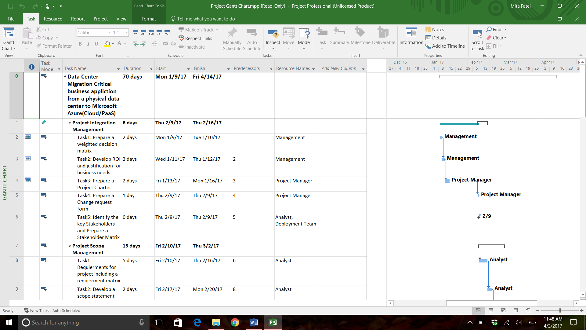

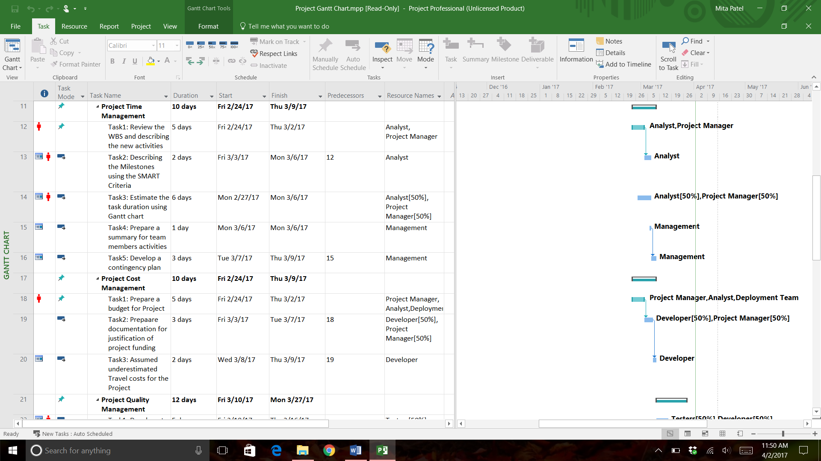

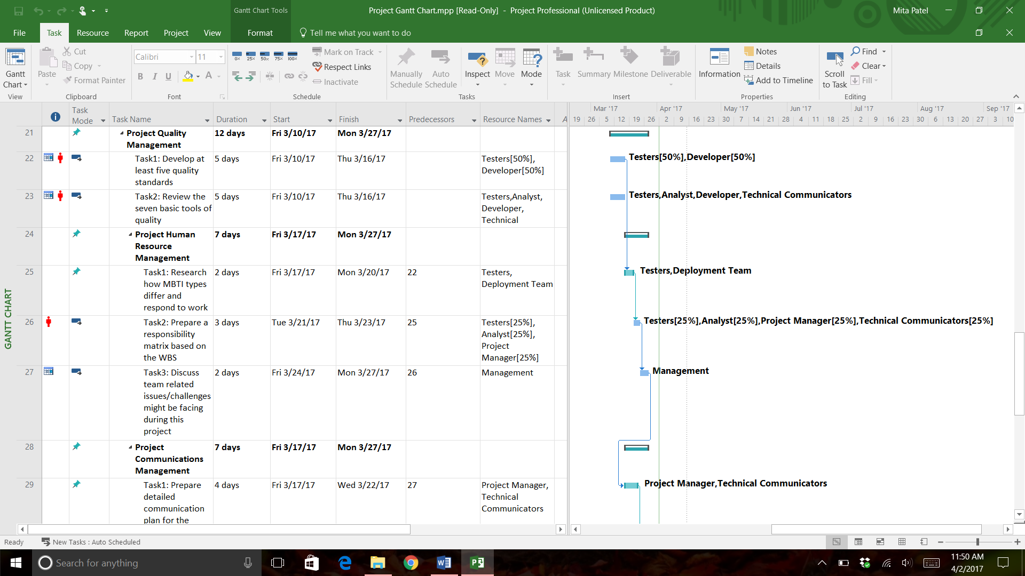

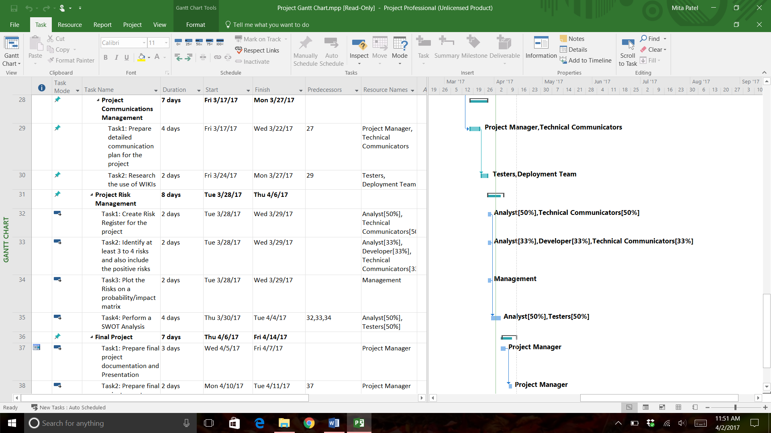

* **Task-4: Write a one page paper summarizing how you would assign people to each activity. Include a table matrix listing how many hours each person would work on each task. -Hint, you are using resource assignment function of Microsoft Project**
* **RESOURCE ALLOCATION:**

Resource allocation is a major part of project management. It stops the teams from juggling and struggling for resources when they need it. As for this migration project, we have a total of 8 members in the group. Now, migration of data from one platform to another requires skill, ideas and methods used to complete the project successfully. In this case, we have a business application that is being transferred from physical data to Microsoft Azure. The platforms are variably different and it is important to test how compatible the latter platform is for supporting the business application. Based on this, we had previous documents making assumptions on the requirements and the budget. Taking those assumptions, a document to allocate the resources to every team member is spelled out below. The team has two members who are also working on developing the technical part of the project. Mittal Patel and Querida Jonquil are creating documents while developing the software and securing the application from being breached in the cloud platform.

The document illustrates two matrices that unfold Human resource allocation and Non-Human resource allocation.

* **HUMAN RESOURCE ALLOCATION:**

As the first part of the document illustrates we have 8 members on the core part of the team and one external member who is the controller. Each person here is a resource assigned with a specific task. The table below displays the functions of the resources and hours required for performing the task.

|  |  |  |
| --- | --- | --- |
| **Name of the person** | **Function/Task assigned** | **Hours required** |
| **Ankit** | Improving the validation document and setting up meetings with the sponsors | 30 |
| **Bhumikka Golwla** | Preparing milestones and handling budgets on the project | 30 |
| **Chirag** | Providing external Non-Human resources for the team when and when required | 25 |
| **Mital** | Writing dependencies and securing the application | 50 |
| **Pinal Patel** | Teamed with Rahul and Bhumikka for preparing budgets and WBS. | 30 |
| **Rahul** | Giving a work breakdown structure and constantly improving the project plan based on the demands of the stakeholders and Sponsors | 40 |
| **Vivekananda** | Preparing contingency plans | 25 |
| **Querida Jonquil** | Allocating resources and giving deadlines while creating code for application development | 50 |

* **NON-HUMAN RESOURCE ALLOCATION:**

There are three resources required to work on the technical face of the project. These requirements have a budget.

|  |  |
| --- | --- |
| **RESOURCE** | **BUDGET** |
| **Installing a new software** | $ 60.00 |
| **Encrypting/Securing** | $ 200.00 |
| **Coding in java** | $ 200.00 |

The above table has a budget prepared with the resource allocated. The cost of the resource changes along with the type of resource used. For example, using java applets to add extra features that support the platform can be obtained from different kinds of online tools that feature a different type of java application. These resources are handled by the two members of the project as mentioned in the first table matrix.

* **Task-5:**  **Based on Your Project Assumed Duration, Develop A Contingency Plan and How You Plan to Make Up Lost Time and Avoid Schedule Slips in The Project.**

Online data storage has proved to be the way to go in today’s business, however, there is the threat of data loss, or even lack of accessibility. A contingency plan is a course of action that a business has in place to handle a future happening that may or may not happen. It is often known as plan B as it may be used by an organization when the intended course of action fails to materialize. To make up for the lost time, there are several courses of action like outsourcing, project crash and even leaving out some of the least important task.

Based on the time that the project is required, we have the option of first talking with the project sponsors, they are in charge of financing what we do and they have the final say in the results, seeking to get a deadline extension does more good that hurrying u and delivering substandard work. Some elf the thing to consider include the need that they have for the project, how prioritized it is and even the funds available to continue holding the project. Depending on their say, we can decide how to important to rank the project and assign the desired weight to it.

Close to this we have the option of working overtime, this does not only produce more, but it also gives room to bond and have a common ground by which we can work. However, there are some drawbacks in this such as the workers losing their morale in a few days, or even producing substandard work. To sort the issues, we can work on shift to see that we still work extra hours and get more as compared to getting to work in the normal hours.

Project clashing has been in use for long, it is one of the most effective and promising way of getting the required results and on time, project clash is all about taking several tasks concurrently. Several resources must be applied to the critical path to see that the time needed to complete given task is brought down. Some of the ways of doing this include the shortening of the required duration or even changing task constraints, this will allow for more flexibility, alternatively, we can look at the methodology that is used in project management, and this will see that new ideas are brought on board.

Project managers also must know on how to fast track task, this will call for all the projects that can be done in parallel being done so, moreover, the projects that are designated to be completed in sequence will be held so. Fast tracking of task allows one to complete several tasks together. More to this, learn how to reject scope change, this will give you the freedom to work at your own pace thus get better results within the stipulated time.

On the other hand, the organization may learn how to reduce their scope, for the task that are not of great importance or which it feels were wrongly allocated to it, this has been seen as a perfect way of dealing with time slips and delayed projects. When all that is impossible, outsourcing has been proven to help sort everything out. There are firms that specifically focus on given aspects of given projects. We can look into the areas that we may need external help and outsource within our budget. Not only is it cheap, it proves to be a cheat code for delayed projects.

Remands

Depending on the situation that the project will be, we may choose one of the listed methods to help avoid schedule slips and delay in the projects. Other considerations will be the timeframe required by the managers, the financial position that we are in and even the availability of workers to work for us, any of the listed methods will be helpful in avoiding this.

**Project Cost Management**

Working with the fact that the IT world is ever changing, we are sure that companies in the past used to hire employees to maintain their systems due to the cost incurred. Today, there is a newer invention known as the fixed cost computing, this enables the companies to get the best out of the computing world. In this the cost is much lower, services are better and there is an assurance of the latest technology in the data and online working scene.

To shift to Microsoft azure, the organization will have to incur some cost; a well-prepared statement helps to avoid the organization from falling short of resources.

* **Task-1: Prepare a budget for your project. A budget should be very inclusive of all cost the project plans to incur throughout the duration of the project including a contingency allowance.**

|  |  |  |
| --- | --- | --- |
| **Project Items** | **Item costs(Hours/day)** | **Total amount** |
| **1. Service Costs** | For total project | $ 7,000.00 |
| **2. Maintenance Cost** | For total project | $ 8,000.00 |
| **3.Hardware**  3.1 Server costs  3.2 Device Cost | 4 servers ($3000 for each server)  Device cost &appliance cost | $ 12,000.00  $ 1,500.00 |
| **4. Software**  4.1. Software Cost   * 1. License cost | 2 Software  3 licenses | $ 2,000.00  $ 3,000.00 |
| **5. Travel cost** | Export and import cost | $ 2,000.00 |
| **6.Training cost & support** |  |  |
| 6.1. Trainee cost  6.2. Team members | Daily payment 12/hour (hours worked per day 8)  Casual worker’s daily payment at 9/hour (hours worked per day 8) | $ 11,520.00  $ 10,368.00 |
| **7. Project Management**  7.1 Project Manager  7.2 Project Team members | $15/hour (hours worked per day 10) (onetime payment)  $13/hour (daily payment) (hours worked per day is 8) | $ 18,000.00  $ 12,480.00 |
| **8. Contingency Plan** | Plan and policy | $ 9000 |
|  | **Total** | **$ 96868.00** |

* **Task-2: Prepare a document defending the budget you have developed and a justification for funding:**

1. **Service Costs:** all the cost $7000 divided in those factors

* Storage space in iCloud (amazon)
* IaaS
* Network configurations
* Application architecture layout
* Azure SQL Database
* Security software

1. **Maintenance Cost:** All cost $8000 divided in those factors

* Computers maintenances
* Microsoft technologies
* Physical environments

1. **Hardware:** overall cost $13,500 divided in these factors
   1. **Device Cost**

* All CPU, Desktops, laptops
* Memory (GB)
* Disk (GB)
* Bandwidth
* Storage
  1. **Server costs**
* Firewalls
* Load Balancers
* Monitoring
* Back up

1. **Software: Overall**: overall cost $ 5000 spend in these tasks
   1. **Software Cost**

* Operating system
* License Agreement
* VMware technologies
* Windows, iOS, and Linux
  1. **License cost**
* Windows license cost
* iOS technology lost
* VMware license cost
* SQL server cost

1. **Travel cost:** overall cost $2000 spend in travelling purpose
2. **Training cost & support:** overall cost $21888 spend training and support team
   1. **Trainee cost:**

* Entering in to new environment, company have to hire trainer, software for training purpose, proper place for training room.

1. **Project Management:** overall cost $ 30480 spend on these criteria
   1. **Project Manager:**

* Lead the project’s most of the part.
* Authority to take sudden change.
  1. **Project Team members:**
* Business analysist
* Developer
* Tester
* Quality control
* Quality assurance
* Security for project
* Subject matter expert

1. **Contingency Plan:** overall cost $ 9000 spent on contingency plan

* Develop contingency plan policy statement with help of senior manager/ program manager/ Business intelligence and Policy maintain maintenance requirement
* Define contingency objectives which based on organization framework and responsibility for migration and planning
* Policy statement have maintained roles and responsibilities, Policy maintain training requirement and Policy maintain frequently backup requirement
* Policy maintain offside storage in any system where we can get back up
* Policy maintain plan exercises and testing for that plan
* **Task-3: Assumed you underestimated Travel costs for this project. Write a one page paper describing corrective action(s) you can take to address the problem**.

Travel cost is a variable cost, bearing this in mind, there is the possibility that it was underestimated, when this happens, the organization and the project manager has some steps at his disposal that they may opt to take. For instance, the best and most immediate one would be to talk with the sponsors and seek for additional financing. When they agree to the proposal then the organization will continue with the travel plans as it was originally suggested.

If they are not able to get additional financing, then the organization may prioritize, this will mean that the less important task can be done away with, then focus on the most important ones. For insistence, the junior workers may be left out in the travel plans and let the seniors travel alone. Moreover, they may opt to cut down the cost, if for instance, they planned to get to a five-star hotel, they may live in a four star that will take lower cost.

The travelling plans may call for them to use a plane, if the need is not urgent, they can opt to travel using an alternative means, e.g. bus or train. Alternatively, if they were to travel on the first-class deck or the business class, they may go to the economy class which will take up fewer funds thus fit to the desired budget. For easy task that can be outsourced, this is the way to go, outsource experts at a lower cost but they provide the same quality.

What about the online meetings, they call for the use of video conferencing to hold meetings; this will cut the travelling cost by a huge margin. Over the years, video conferencing feature has been perfected to a point where people can communicate with ease. For the organization, all that can be done on video should be done on the video.

**Project Quality Management**

* **Task-1: Develop at least five quality standards and or Requirements related to meeting the Stakeholder expectations (Mital Patel, Querida and Chirag Modi)**
* **What is Project Quality Management?**

The project Quality Management defines the level of quality. Customer, deliverables and work processes define these quality levels. Customer’s satisfactions are main standard for any Project Quality Management.

* **Quality Management plan guarantees the following:**
* It depends on project developing standards and requirements.
* Project performance or effective work process and proper justifications.
* Providing correct activities for non-conformances systematically.
* Quality assurance, quality activities, quality circle and quality audit define quality standards.

For effective performance of any successful project we have to create Project Quality Management Plan. This depends on five project developing standards like Initialization, Plan, Executing, Monitoring, Controlling and Documentation.

Now, these five phases based on Project Quality Management as given below processes:

* **Project Initialization based on Quality Management:**

In this quality standard, we decide the scope of the project and requirement. This is deciding some boundary of our project.

* **Project Planning based on Quality Management:**

The project planning means plan to quality of one effective project. This also included all quality standards like quality assurance, quality control, quality audit, quality activity, etc. The outcomes of the project quality planning are process improvement plan, quality metrics, quality checklists, quality management plan and project documents changes.

* **Executing of project based on Quality Management:**

The executing project means running level of project. This process is Perform quality assurance. The process outcomes are project management plan updates, change requests, project documents updates and Microsoft company process asset updates for Azure cloud based on rules of PaaS.

* **Project Monitoring and Controlling based on Quality Management:**

This process performs the quality control. The process outcomes are Quality control managements, validated changes, validated deliverables, work performance information, change requests, project management plan updates, and project documents updates and updates Company process asset.

* **Project Final Documentations based on Quality Management:**

This phase of project quality describes briefly about project qualities and justification of every step of work process.

This project quality assurance is meant to be designed to meet our needs on the success of the project and meet the requirements of the stakeholders. In the process of data-migration we determine the quality of the data that is being transferred. Quality assurance is branched into two types. Testing based methods for the technical side of the project and project management based method for the business side of the project. This assurance is carried out in three stages:

* Plan quality management which involves checklists and updates on document.
* Performing the above task to see if there are any changes required.
* Monitoring and controlling stage where changes made on the above two tasks are validated.

Assurance of the migration comes with benchmarking. Here we compare our project with other migration related projects.

The following are the seven tools used in auditing the quality of our project:

* **Using checklists**:

This tool is a document that checks (x) every task that is completed so far. It is helpful in maintaining schedules and gives a clarity on how fr we have reached in the project development life cycle.

* **Flow charts to solve problems**:

Flow charts are the diagrams that give a pictorial representation of how to solve any query or meet a deadline. These diagrams are preplanned and are designed before the project begins.

* **Seven run rule**:

This is a quality checking tool which helps us look for patterns in the data for examining if there are problems in the development. These patterns occur based on the mean calculated from a graph.

* **Relationship table**:

This tool is like seven run rule. The former finds out patterns for problems and the latter finds the relationship between two quantities.

* **Graphs**:

All the above two rules are found out based on histograms we draw towards the conclusion of the project.

* **Pareto charts**:

This is a chart that shows the clarity in the problems and the causes of the problem in the project. These charts as well depend on histograms.

* **Run charts**:

Run chart is similar to a flow chart. The only difference is Run charts show the history of the patterns and problems in the project to give a result if we are on the right track of solving problems.

Finally, a six-sigma test is run to see if our project is meeting the requirements of the end user.

* **Requirements related to meeting the Stakeholder expectations**

|  |  |  |
| --- | --- | --- |
| **No** | **Expectations** | **Requirements** |
| 1. | Calculate the data. | To get the assumption of the storage we need to calculate the whole data what we have. |
| 2. | Choose the perfect data model | We wanted to implement the data into the cloud as PaaS method. So, we need to choose a perfect model which we are going to use. |
| 3. | Planning and Executing | When we are thinking about the implementation, we have to plan the whole method that how we are going to implement. And for that we have to meet together to share everyone’s idea. |
| 4. | Design | If we are choosing PaaS method for our data we need to design the system to fit in the expectation of the stakeholders. |
| 5. | Meetings | In between the project when everyone is doing work together, the company need to be uptodate.with every updates. And for the any query or problem they need to be together as a meeting so that they can discuss all the problems with everyone. |
| 6. | Gantt Chart | A Gantt chart aids in scheduling, managing, and monitoring specific tasks and resources in a project. The chart shows the project timeline that includes scheduled and completed work over a period. The Gantt chart aids project managers in communicating project status or plans and helps ensure the project remains on track. |
| 7. | Cost Saving Model | We are going to use the Microsoft Azure. They have their own packages which we can customize it and get the things only which we need. So, that we can save the money for the things which we don’t want. |
| 8. | Trial | After selecting everything, we have to trial it in the real scenario. When we are trial it we can get the idea about what are the things6which we need to change. |
| 9. | Deadlines for the Trial | Because of the short period of the project we don’t have much time. So, after the 30 days of the project stakeholder need to check what is going on in the project. |
| 10. | Fix the Bugs | When the company put together their all data and do the trial, the result will not be going to be positive only. So, if the result is negative they need to modify it. Otherwise they can continue for the implementation. |
| 11. | Budget justification | You need to prepare the budget for the showing that you are going to allocate these much of the money in the project. |

* **Task-2: Review the seven basic tools of quality. Pick one and make up a scenario related to your chosen project.**
* **Quality tool: Check sheet for data transfer to Microsoft azure**

During data transfer to Microsoft azure, project team has made check sheet that certain things to be taken care of. Check sheet will keep record that actual work is completed as per requirement within time. Therefore, we have 5 different tool for check sheet are 1. **log in, 2. security, 3. software and hardware requirement, 4. backup plan and 5. scalability.** While moving to azure, we have login detail that should be fulfilled. How many users are accepted to move data on azure? This question should be answered at early during project. In our project, we allowed project manager and team leader as user login for data migration. After that data security is major part for migration. When data is transfer to azure, project manager and team members must show attentiveness about data security. Another part is technical requirements. What kind of tools and equipment will be requiring for data migration efficiently? From software to hardware equipment and network requirement. These all necessary parts must be ready before migration on azure. In case of data migration failure, what will be back up plan to continue data migration. The robust plan should be ready in case actual data migration fail. The server scalability tool will also be helpful. Which will measure higher data transfer scale and lower data transfer scales, which will allow project manager to how much access data transfer and to control on it. Therefore, in quality management check sheet will measure login, data security, technical requirement, backup plan, server scalability. In our scenario part, we used server scalability that how much time server stop migrating data due to excessive load in a month. So, whenever server shows higher scalability, it will stop working and will show alter signal. So, during whole project work, server scalability was higher due to excessive load while very less time it happens that server showed lower scalability. We measured it during once in a month that how it works and showed scalable signal. We found that during weekdays and particularly Monday is higher scalability while during Saturday, scalability declined.

Higher occurrence and requirement to maintain in check sheet is scalability. Points out of 10.

* **Given below Example of check sheet during data migration**

|  |
| --- |
| 1. Start date of data migration: |
| 1. End date of data migration: |
| 1. Team members involved in migration project: |
| 1. Is user logging implemented?   Yes 🞏 No 🞏 |
| 1. Does Microsoft azure have limitation for data storage?   Yes 🞏 No 🞏 |
| 1. Does data can be used while transfer to Microsoft azure?   Yes 🞏 No 🞏 |
| 1. Data types: records 🞏  * Information related to customer 🞏 * Confidential information of workplace🞏 |
| 1. Does data fit or able to transfer on cloud?   Yes 🞏 No 🞏 |
| 1. Is user permission allowed more than one person?   Yes 🞏 No 🞏 |
| 1. Does information be used except migration team during data transfer?   Yes 🞏 No 🞏 |
| 1. Data monitoring plan: describe in brief. |
| 1. Is Robust disaster recovery plan ready?   Yes 🞏 No 🞏 |
| 1. Data transfer requirement:   software:  hardware:  network equipment: |
| 1. Has the current level of quality for transfer been assessed?   Yes 🞏 No 🞏   * Describe any defects or problems while transfer.  1. Does Microsoft azure have limitation for data storage?   Yes 🞏 no 🞏 |

**Project Human Resource Management**

* **Task-1: The entire group should go to www.humanmetrics.com and take the short version of the Meyer Briggs Type Indicator (MBTI) and share the result. Share amongst your selves. Research how MBTI types differ and respond to work. Summarize your finding in a one to two-page paper.**
* **Chirag Modi**

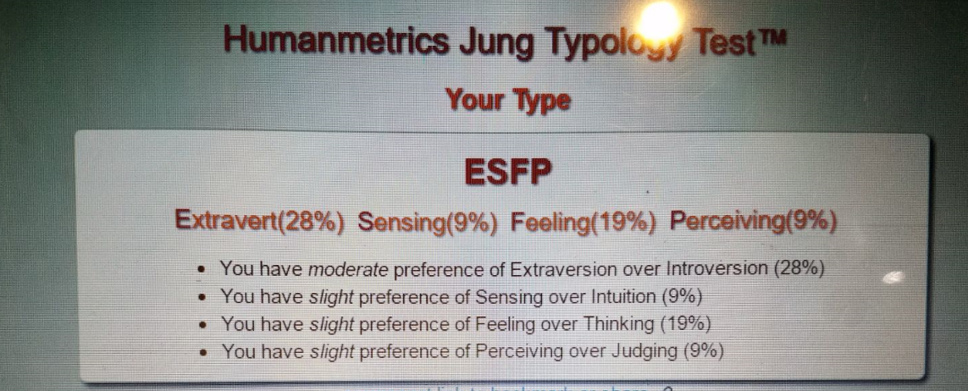

Personality is a different type of the characteristics which describes a person’s character. So, every human being have their different personality. My score of the Human metrics Jung Typology Test is Extravert 23%, Sensing 9%, Feeling 19% and Perceiving 9%. I think that, I found that my 40-50% personality was right. However, a machine cannot judge any personality. I guess so the main concept of the personality test is our answers. In the questioner, they ask you the questions and you need to answer the question in Yes, No or Uncertain. When I was doing the test, I have noticed that some of the questions are asked again and again in different way. By seeing your consistency or differentiation in the answer machine will give you the result. Let’s assume If you have asked you something and you said yes then after few questions they asked you same question in the different manner. So, it will check both answer which are same or not and then it will give you the result.

* **Pinal Patel**

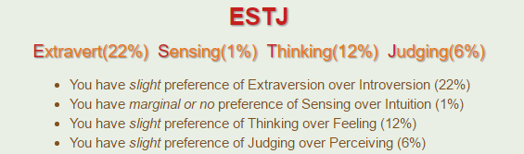

* I am really extravert person.
* I can take decision by myself in any situation.
* I can also easily lead myself or my group people.
* I am not person like take decision emotionally.
* **Mital Patel**

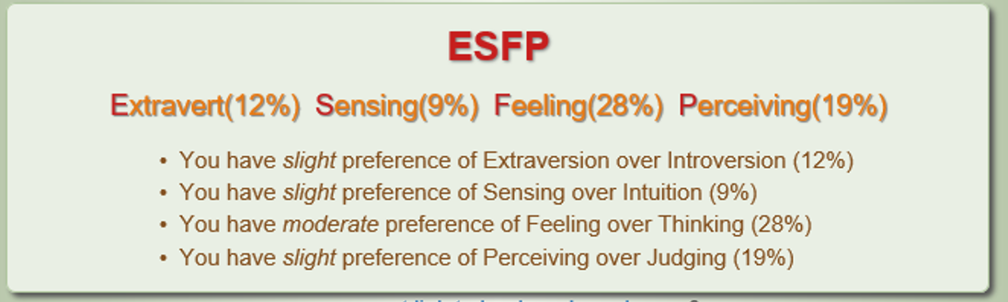

The result of Briggs Myers theories of personality type, my characterizing personality is “ESFP” stands for Extravert, Sensing, Feeling and Perceiving. As above result as a personal my nature is loving, excitement about plan, share good stories and enjoying with friends. I also love to talk with friends and familiar persons. As a nature like to try new ideas, new trend and new technology. The ESFP nature person identifies someone thoughts by talking with them a few minutes. Some organizations also like to ESFP area for social work or social counselling. In business communication among ESFP is participating in solving current problems related to advertising or sales marketing and public relation. ESFP ‘s nature person can manage to find sudden solutions to giving practical examples where creating trusting and warm environment. ESFPs person has wonderful imagination power for learning a various practical applications and problem solving in business.

* **Rahul Parekh**

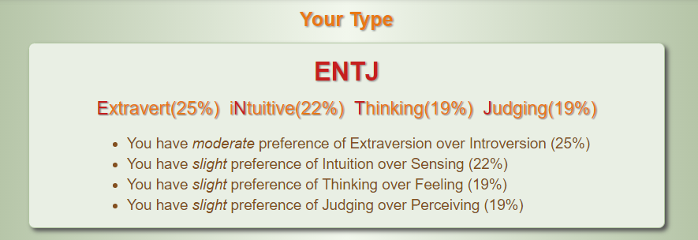

My test result it ENTJ. It means a person with extrovert personality who like to be with people. A person who share thoughts and understand others. I don't let things happen in my life so I am intuitive kind of person. I believe to be think rather than feel the matters. It is very hard for me to take decision when there is feeling involved but I can take decision what I can think. Therefore, it is better to work on places where I must think, judge and work. when organization should take work from their employees and want them to take decision on base of understanding but not by feeling. Such organization like Army, adventure groups.

* 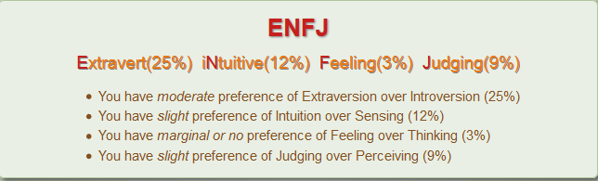**Ankit Rao**

As per Briggs Myers theories of personality test, my characterizing personality is ENFJ means Extravert, Intuitive, Feeling and Judging. The test was very accurate and it helped me how to develop my personality skills and pros and cons of my characterizing personality. As above results I am a person who loves to talk to people socially. It tells that I am extrovert person and I prefer to talk to people very often. I have feelings but I never relate with what I think in doing things. From above result Feeling (3%), feelings don’t play a major role when I am thinking, I believe that when feeling and thinking are related the output will be a disaster and I don’t want to regret for that in future. The test also shows that I tend to have a slight preference of judging over Perceiving. I find this to be an advantage in my work place as this would mean that I would judge a decision based on facts and rather than just perceiving the overall outlook.

* **Querida Jonquil Doddamani Jaysheel**

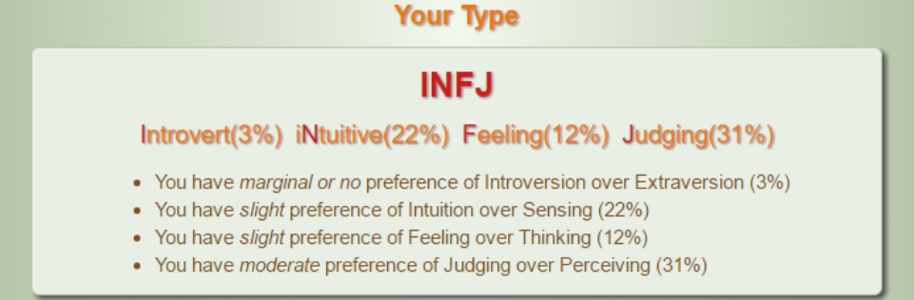

The human metrics test is a personality test which has been set up to define the character of a person. The results of my tests are displayed above as you can see. The assumptions from these tests are never always accurate. The reason for it Is the situation (or) mood of the person at the time of taking the test. Anger, sadness emotional mentality of the person cannot be read by the machine. This can fluctuate the answers and thereby give a different personality review.

* **Bhumikka Golwla**

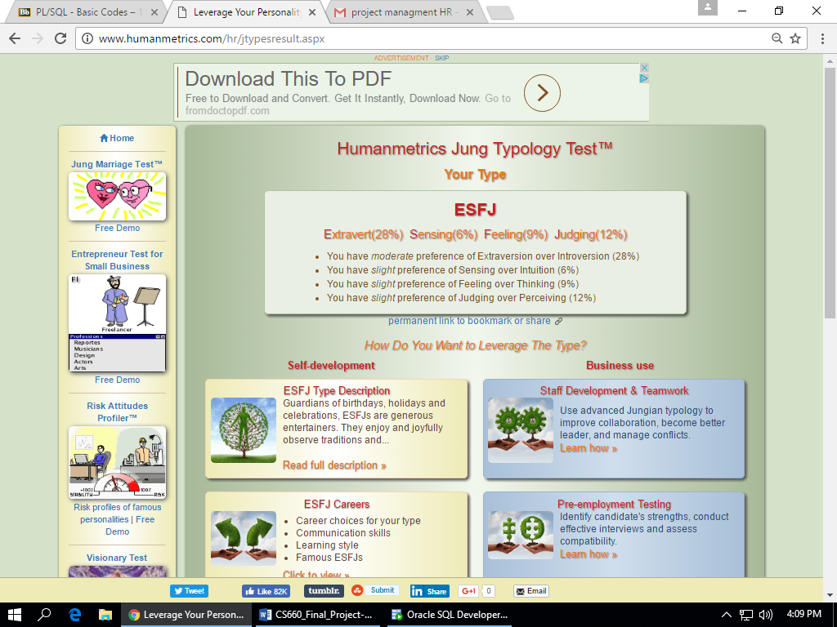

I am an extraversion person as I like to talk with everyone and like to hang out with friends. I am comfortable with everyone even though I meet them for the first time. My thinking power is less compared to feeling, as I like to take decision by feelings rather than thinking as don’t always think about my profit. I judge the opposite person very fast and react on it. I can sense the opposite person after knowing him for a quite some time but my intuition power is very low compared to sensing.

* **Vivekananda Ravva**

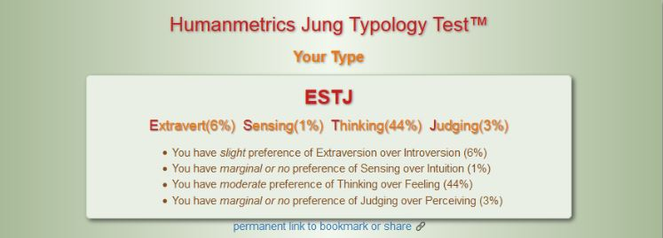

ESTJs identity sort are esteemed for their unmistakable exhortation and direction. I cheerfully lead the route on troublesome ways. I’m taking pride in uniting individuals ESTJs frequently go up against parts as group coordinators to unite everybody. I live in a universe of truths and live in the present, with their eye continually examining their own condition to ensure that everything is running easily and methodically. I’m assume responsibility individuals.

* Here, we can see the all project’s team members MBTI test results. Chirag’s test result is ‘ESFP’. His Extravert is 28%, Sensing is 9%, Feeling is 19% and Perceiving is 9%. So, He is good for Human Resource Manager position. Pinal’s test result is ‘ESTJ’. Her Extravert is 22%, Sensing is 1%, Thinking is 12% and Judging is 6% so, she is good for Project Manager. Mital’s result is ‘ESFP’. Her Extravert is 12%, Sensing 9%, Feeling 28% and Perceiving 19% so, she is good for Business Analysis Manager. Rahul’s test result is ‘ENTJ’. His Extravert is 25%, Intuitive 22%, Thinking is 19% and Judging is 19%. So, He is good for Program Manager. Ankit’s result is ‘ENFJ’. His Extravert is 25%, Intuitive 12%, Feeling is 3% and Judging is 9%. So, He is good for Developer Manager. Querida’s result is ‘INFJ’. Her Introvert is 3%, Intuitive is 22%, Feeling is 12% and Judging 31%. So, she is good for Quality Manger position. Bhumikka’s result is ‘ESFJ’. Her Extravert is 28%, Sensing is 6%, Feeling is 9% and Judging is 12%. She is a Stockholder. Vivekananda’s result is ‘ESTJ’. His Extravert is 6%, Sensing is 1%, Thinking is 44% and Judging is 3%. So, He is Employee for this project.
* **Task-2: Prepare a responsibility matrix (RACI format) based on the WBS created.**

|  |  |  |  |  |  |  |  |
| --- | --- | --- | --- | --- | --- | --- | --- |
| Role  Project Deliverable  (or Activity) | Adviser | Functional Manage | Project manager | Sponsor | Team Member | Developer | IT manager |
| Initiate Phase Activities |  |  |  |  |  |  |  |
| - Business case | A | C | R | I | R | I | I |
| - Project charter | C | A | C | I | R | I | I |
| - Plan scope management | C | C | R | A | A | I | I |
| - Key mile stone | C | I | R | I | A | - | - |
| - Budget of project | A | R | R | C | A | R | R |
| - Agreement | I | A | R | R | R | C | C |
| Document |  |  |  |  |  |  |  |
| - Requirement gathering by JAD session | A | R | R | C | A | R | R |
| - Create BRD document | C | A | R | I | R | I | I |
| - Approved BRD | I | I | R | A | A | I | I |
| - Create FRD document | C | A | R | I | R | I | I |
| - Approval FRD document | I | I | R | A | A | I | I |
| - Available for technical team | A | C | C | I | A | R | R |
| Execution |  |  |  |  |  |  |  |
| - Design system | C | C | C | I | C | R | A |
| - Arrange meeting with managers | A | R | R | A | R | I | I |
| - Produce hardware and software | A | R | C | R | C | R | R |
| - Review with client detail | A | C | C | I | R | R | R |
| - Testing | A | C | C | I | A | R | R |
| - Deployment | I | C | C | I | A | R | R |
| Maintenance and control |  |  |  |  |  |  |  |
| - Revision | C | A | A | I | C | R | R |
| - Problem identification | C | A | A | I | A | R | R |
| - Meeting with manager | C | A | R | A | R | I | I |
| Closer |  |  |  |  |  |  |  |
| - Implementation of project | C | A | A | I | C | R | R |
| - Compare actual with projected work | C | A | R | I | C | A | A |

* **Task-3: Discuss any team related issues/challenges you might be facing with getting work done and working together.**

An ideal team also having some issues into team. But as an ideal all members of team do their work best and ignored small issues. What kind of issues/challenges might be facing with work together? This issues/challenges are explain given below:

* **Lack of trust:**
* Trust is crucial to team work and it starts with team members knowing each other. Team members absolutely need to know each other professionally and personally.
* **Conflict and tension:**
* Conflict, a difference in opinion can be carefully managed it can trigger using debates.it can make people think differently, expanding knowledge and insight and innovation can happen and results flourish. Different opinions are not a bad thing it’s how we handle the conflict that makes a difference.
* **Not sharing information:**
* Team members all have unique set of knowledge, skills and ideas they all should come together and discuss on the information so that leads to an innovation, and development of the organization. This makes the capability of the whole team grow and gives team power.
* **Low management:**
* Team management is essential for business success. Team members who are engaged are interested in what they do. Committed to team mission, willing to going the extra mile. The key role of management is by involvement, by involving others to make it.
* **Low transparency:**
* The superior of the company must be more responsible by making the employees follow the leaders. When this is done, it can have a positive cascade effect throughout the organization.
* **No long-term thinking:**
* Business must get beyond day to day urgencies, be able to take holistic view, see the big picture and how all the party fit together and how you impact the customer experience and valve proposition. This is about business sustainability; long term success requires long time thinking.
* **Badly perceived, not delivering:**
* A team should have good brand image, brand loyalty, and reputation for the product they are created by the actions and behaviors of the team members. A large part of perception is driven how the team delivers and the expectations. As a team, everyone should understand their responsibility and creating a perception of the team.
* **Poor change management:**
* Changes of the team are constant. They should carefully have managed unless the teamwork gets the results. Changes start and ends with communication it involves interactive, listen talk and getting involved and should be careful of the changes in the curve. The stages of the curve are resistance, emotional, hopeful, commitment. Each stage should be managed and should be kept minimum.
* **Working in silos**
* Silo working is a reality for many teams. Team members may sit side by side but not together. A great team can be of three types –all for one and one for all. Working in teams is like thinking yourself as a full-time member in the team and not thinking of individual perceptive.
* **Not going in the same direction:**
* All the team members don’t lie on the same point they are discussing on. They don’t go in the same direction. Spending time on your vision with your team. this provides you a framework and reason to be in the team.

**Project Communication Management**

* **Task-1: Prepare a detailed communication plan for your project.**

In communication planning, we will be covering communication needs and communication content development. Communication needs planning in which we will take information and the needs of communication among affected teams, end users and stakeholders. We will describe communication development in which we describe our key messages and communication principles of which people and stakeholders have agreed upon. In this communication project manager, will play the vital role. When we decide to move data into azure, we subscribed into azure and we try running behind it rather than doing with patience’s.

In communication, we need to take care of the documentation of the group list and also priorities of each ever member in the audience group which are key stakeholder, executives, developer and also IT manager.

* **Principles of Communication:**
* We should try communicating in the manner through which employees believe in the project goals and run after that goal.
* We should try involving every member in the project rather than just informing about the project.
* We should make everyone respect the communication among each other than only work will be done properly and on time.
* We should give credibility to communication to give commitment to shareholders.
* We should have feedback from every member of the team.
* Accurate and limited information should be provided to team members as more information provides confusion among them.
* There should be consistency in the work as this will help to complete it on time and remembers will not get frustrated.

The below channels should be agreed upon by all personnel’s and should be finalized. Communication should be the priority before any actions among the team members and first- wave.

|  |  |  |
| --- | --- | --- |
| **Audience** | **Communication** | **Channel** |
| **Stake holders** | Update of the process. Discussing the goals and status of the project. | Through presentation, and in personal. |
| **Executives** | Explaining the benefits. Understanding the time for completion. Updating to manager about the project update. | Through meeting, emails |
| **Developers** | Impact of the activity or action during migration. Also, explaining the opportunity of training. | Discussion verbally through meetings with IT manger. |
| **Employees** | Explaining the benefits of azure. The timeline to complete the whole project. Provide the employees with some training about azure. | Discussing should be done through emails, meetings. Company portals also help to know about the project. |

* **Task-2: Research the use of WIKIs and address the concerns team members have about using them, and the fear of others “messing up their work” document your finding in a one – to two pager paper.**

Research the use of WIKIs and address the concerns team members have about using them, and the fear of others “messing up their work”

Wikis have proven to be an effective way through which students can write about a specific subject. By relying on metacognition skills, they can explain the various concepts that they hold in a way that will be understood by all. Moreover, wikis enable student and group members to do their work independently; moreover, when the students cannot meet at the same time, the members can edit the work at their own time.

For the members, they are able to apply the use of technology, such as writing and research skills to do their work, within a time fraction; they will have a product that they can show to their peers. It’s a great tool to help the students perfect their mastery skills besides writing of reports and tests.

However, there is the danger of having the work edited; this is one of the biggest drawbacks in the use of wikis, a well-researched piece of work may be messed up through an addition of false or biased information, thus rendering them ineffective. Compared to research journals and books, Wikis tend to focus on the surface information, failure to reach the depth of information that is required by the students often end up messing the entire process.

Besides this, they heavily rely on the use of computers; thus, anyone with no computer and internet connection will have a hard time using them. As the information on them was not based on research, there is a threat of the information becoming obsolete. For team members, there is a need to meet and discuss on the way forward more often, wikis make people meet less and thus disagreement may results, eventually, work will be messed up.

**Project Risk Management**

* **Task-1: Create a Risk Register for the project.**

|  |  |  |  |  |  |  |  |  |  |
| --- | --- | --- | --- | --- | --- | --- | --- | --- | --- |
| **Id no.** | **Rank** | **Name of risk** | **Description of Risk** | **likelihood** | **Root cause** | **Triggers** | **Potential responses** | **Risk owner** | **Impact** |
| R14 | 1 | Data protection | It is hard for a user to check data management while transfer | High | More number of log in users allow in process | It can occur in future. | The steps will be taken for it | Project manager | If data is not protected, data transfer is not usable |
| R51 | 2 | software management | It is very complex to change or edit in update after data transfer to azure if software not managed. | high | Software installation and not regularly update | Currently facing problem | Team members are working to solve issues | Software department | Loss of data while transfer to Azure |
| R19 | 3 | Internet connectivity | Lots of internet connection can prevent data transfer on azure | Moderate | Improper devices and lack of control from Microsoft azure | There is no problem now but can occur if not check | Need to give attention for future safety | Project manager | All access can be terminated while actual work is going on |
| R60 | 4 | Record retention | When data retention require, Microsoft azure must have features for future record | Low | Lack of communication between team data transfer and azure team | Proactive feature for future reference | Teams have to communicate before it make disaster | Project members and Azure team members | All records may not retain and it could affect whole project when data is not available |
| R32 | 5 | Security | It is combination of confidentiality and prevention of unauthorized information | moderate | Lack of standardization control in cloud | Due to dynamics of azure, techniques control security fall short | Advanced techniques require | Project manager | Data leak and unauthorized user can involve in project |
| R34 | 6 | Backup | Once data transfer to azure, data backup after the process to use again | High | Due to incremental backup after every set of data transfer | Improper plan and gap in communication may occur in future | Set backup data whenever data is moved | Team members | Chance of lost data if back up is not taken |
| R26 | 7 | Data redundancy | Same data store at different place more than two times | Low | Lack of communication in data transfer and guidance in data transfer | Right now, no point of occurrence but wrong methodology is chance of it | Can be avoided before data transfer | Project manager | Dual work for team members and difficult to remove data from both sides |

* **Task-2: Identify at least 3 to 4 potential risks and include positive risks as well.**

**In the Microsoft azure potential risk and positive risks are,**

* If any document or application stores and retrieves very sensitive data, company cannot store maintain into the Microsoft azure. As a same way compliances requirement is also in limited choices.
* Once everything is running good in existing set up, there are not more demand to maintenance, scaling, availability, and all the things make migration successful. But some point maintenance, availability, and scaling.
* Some technology which we rely on is proprietary, may not be legally deploy it into the Microsoft azure.
* Some process or operations may suffer from added latency while using Microsoft azure.
* After some level might lose transparency and control. Also, debugging performance issue because of losing controlled on some of the part.
* Shared resources are also making problem for migrating data to Microsoft azure.
* May be application design and architecture design is not completely follow by distributed cloud architectures or may be require some modification on transferring data or Microsoft azure application.
* Might have fear with unknown challenges.

**Main component for Microsoft azure risk management:**

* Greater dependency on third parties:
* Aggregated data centers are increasing risk
* In external interfaces is increasing by vulnerabilities
* Immaturity of the service providers with the potential for service provider ongoing concern issues
* Increased dependence on free confirmation forms
* Increased complexity of compliance with laws and regulations:
* Greater extent of protection risk
* Trans border flow of personally identifiable information
* Affecting contractual compliance
* Reliance on the Internet as the primary conduit to the enterprise’s data introduces:
* Security issues with a public environment
* Availability issues of Internet connectivity
* Due to the dynamic nature of Microsoft azure:
* The location of the processing facility may change according to load balancing
* The processing facility may be located across international boundaries
* Operating facilities may be shared with competitors
* Legal issues like liability and ownership relating to differing laws in hosting countries may put data at risk.
* **Task-3: Plot the risks on a probability/impact matrix. Assign numeric values 1 – 10 to each risk with one being the lowest and 10 the highest.**

Every project is subjected through an uncertain and risky environment to accomplish its tasks. These risks can be positive which can bring good results and negative which can be harmful if they are overlooked. For this reason, every project at the beginning of designing scope, certain risks that the project could face in the future are documented and managed. Having the risk management chart, we can calculate the probability and impact of risks in data migration. This chart narrows us down to 4 key risks ranging from low risk levels to critical risks.

The cons of not managing risks could form on the project in the form of heavy financial loss. It can also be considered as waste of time and resources. To save our project from all that “drama” it is highly important to have risk management.

We now discuss the risks that could occur in migration of software. This is represented in the following graph on a scale of 1 to 10 with 1 being the least risk and 10 being the highest and the most critical risk.

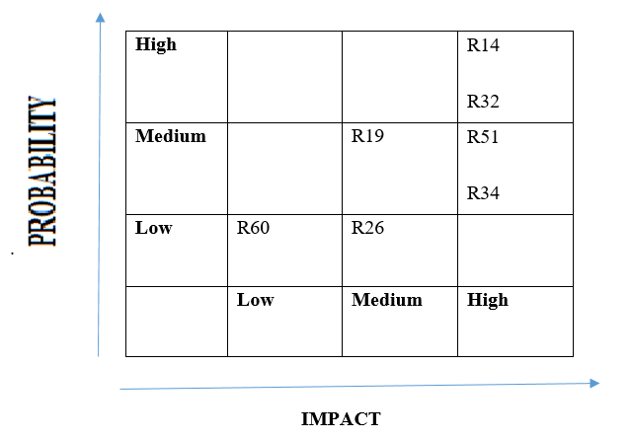

The above probability/impact matrix shows the seven risks of migrating software project. These risks can be defined in the following four types:

* **High probability/High impact**: The data protection and security of the data are having the high probability of going wrong. The impact of these two risks is therefore high.
* **Medium probability/High impact:** Backup of the data and software management are the risks that could probably occur. These can be taken care of while designing but if not completely aware the impact of the risks is going to be high due to which we will have to reconstruct the project again.
* **Medium probability/Medium impact:** Internet connectivity plays a role in software development. The probability of losing internet to work is medium and this can cause a wastage of time of not fast. Hence the impact is medium too.
* **Low probability/Medium impact:** Data redundancy is a cause of errors in the coding part of the project when a new code is being developed for developing the software or the business application. There is a chance some errors could cause data redundancy. The probability of this risk is low but impact is medium.
* **Low probability/Low Impact:** There is no such thing as 0 impact, as it means that there is no risk. Hence the low impact and less probability of any risk is considered but is not very deeply concerned about. Record retention is a part of the risk but not a threat. It is necessary to see the records before any new feature is added.

|  |  |  |
| --- | --- | --- |
| **Risk** | **ID** | **Rank** |
| Data protection | R14 | 10 |
| Software management | R51 | 9 |
| Internet Connectivity | R19 | 4 |
| Record Retention | R60 | 1 |
| Security | R32 | 8 |
| Backup | R34 | 7 |
| Data redundancy | R26 | 5 |

On a scale of 1 to 10, the risks based on their IDs, I give the following criterion to the seven risks:

* **Task-4: Perform a SWOT Analysis:**
* **Strengths:**
* Microsoft Azure can count on several good arguments to attract financial institutions.
* Microsoft Azure will fill up the need of these organizations that require to run mission critical applications levels of availability, security and availability.
* safe test environments in which they can mirror their own computer systems and then make changes or updates without the risk of crashing
* Flexibility is the cost structure of cloud computing that is not considered as capital expenditure anymore.
* More flexible business model that lowers operational costs.
* Cloud services can drastically shorten deployment time by creating for instance virtual desktops.
* Developing a suitable software infrastructure internally could take up task to the expertise of cloud providers
* Save a lot of time especially in the development and testing phases of implementation.
* **Weaknesses:**
* Major drawback of cloud services applied on security and privacy issues
* Most of the time the corresponding data centers are located in a totally different place thousands of miles away which make them unsafe.
* In the future, a spread of data centers at the local level especially if corporations need to make it safer.
* Regulation and compliance.
* **Opportunities:**
* Cloud services should be an important catalyst in the transformation and improvement.
* Banking customer service and personalized service will be of great importance.
* Any system is more interaction and simplicity.
* Cloud services could be really helpful to deal with that type of fastidious administrative process
* Cloud services should also make the communication between two company or employee and customer, this is easiest way to sharing documents, spreadsheets on a virtual cloud accessible to all employees or organization.
* Flexible architecture with capacity of expansion. For example involving huge levels of calculations.
* **Threats:**
* Security breach could result in a wave of mistrust in the organization and consequently damage its image.
* Modern IT infrastructure at monthly fees of less than $10,000 instead of having to invest millions of dollars upfront to build their own secure data centers.
* This cut in launching costs should be a major revolution in various industries as it will probably reset the ratio of power between the different players.

**References**

* Akintoye, A. (2010). Analysis of factors influencing project cost estimating practice. *Construction Management & Economics*, *18*(1), 77-89.
* Kujala, J., Brady, T., & Putila, J. (2014). Challenges of cost management in complex projects. *International Journal of Business and Management*, *9*(11), 48.
* Martinelli, R. J., & Milosevic, D. Z. Cost Management. *Project Management ToolBox, Second Edition*, 273-300
* Boulos, M. N. K., Maramba, I., & Wheeler, S. (2006). Wikis, blogs and podcasts: a new generation of Web-based tools for virtual collaborative clinical practice and education. *BMC Medical Education*, *6*, 41.
* Pei Lyn Grace, T. (2009). Wikis as a knowledge management tool. *Journal of knowledge management*, *13*(4), 64-74
* Website: http://mission.sfgov.org/DOCUMENT_CENTER_DOCUMENTS/DC3866.pdf